Plan of stress testing

Testing the limits to see how much concurrent users The webapp can take and for how long.

**Why?** Scalability – performing a stress test on the web app will show how much users can be supported and how soon the webapp will need before it needs it scaled up to handle more users.

Testing this webapp will also show any bottlenecks that may exist within the application?

Tools to be used:

ParrotOS

Siege

Results:

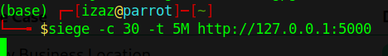

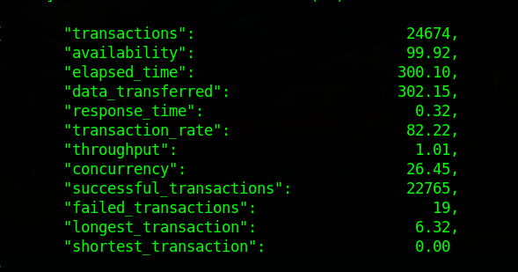

This is running 30 concurrent users for a period of 5 minutes. The webapp can handle this load of users with a success rate of 99.92%.

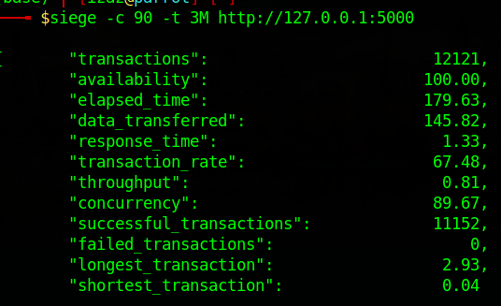

I had adjusted the parameters further to have a shorter time but more concurrent users and it seemed to work even better than the last test where it ran for 5 minutes.

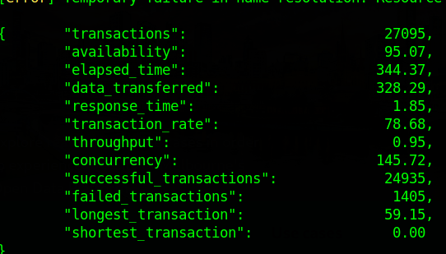

I ran the test with 255 concurrent users for 10 minutes and it seems as if the webapp may start to get a slow but is still able to handle that many users at once. To test further I will need to change the config file file. There were a few errors (below)





Suggestions on optimizing?